**Flutter Project Note:**

1. Light / Dark Mode

You can switch the app theme mode(Light mode/Dark mode) using the Moon/Sun icon on the left-upper corner:

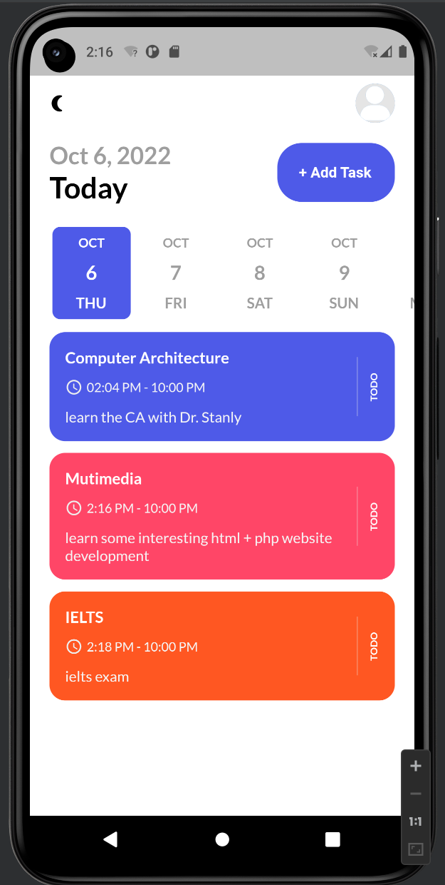 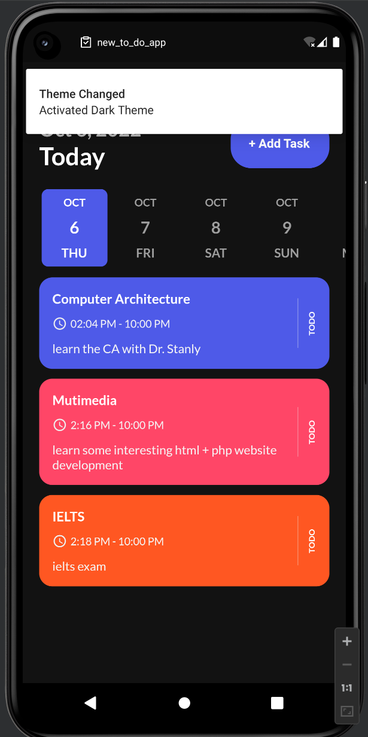

Light mode Dark mode

1. Remind function

You can set the remind and repeat function in particular time then the app will remind you in the form of app message on your phone reminder bar.

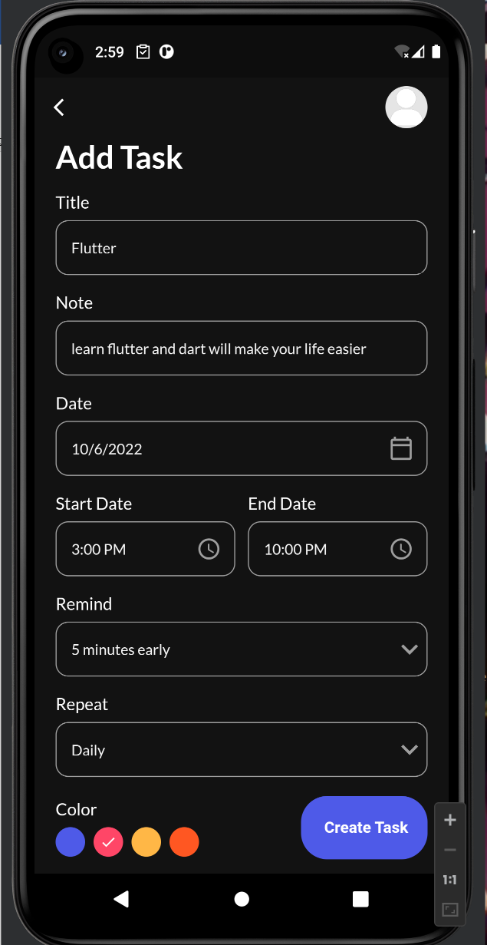 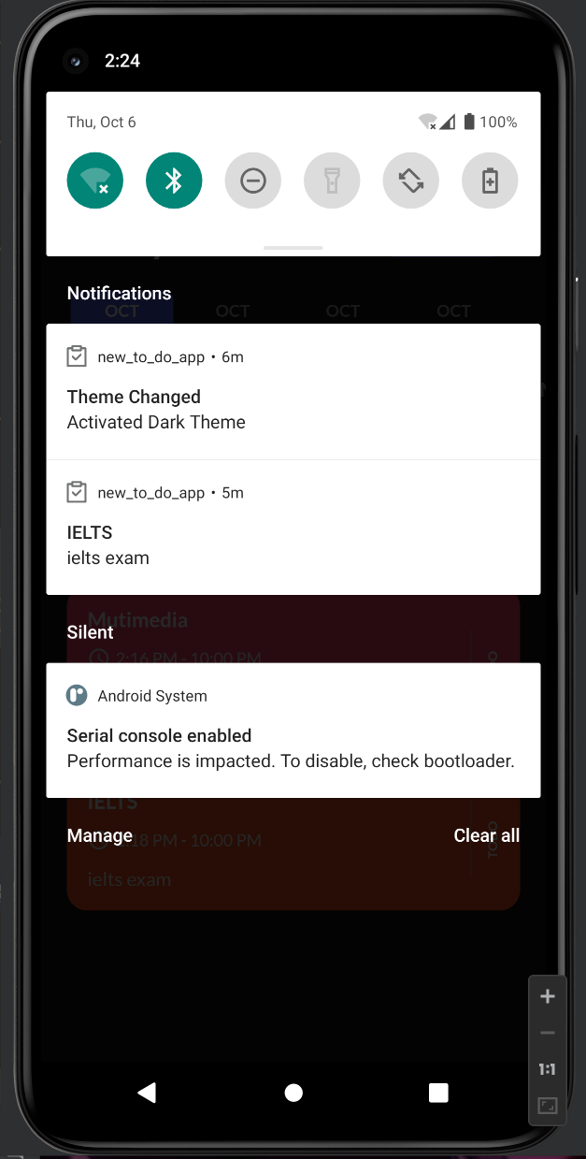

Set remind(5m early than task start time) Task remind message on phone

*Consider set the Deadline remind?

1. Add task list(remind, color, repeat..)

You can add some tasks and set its time reminder and task theme color.

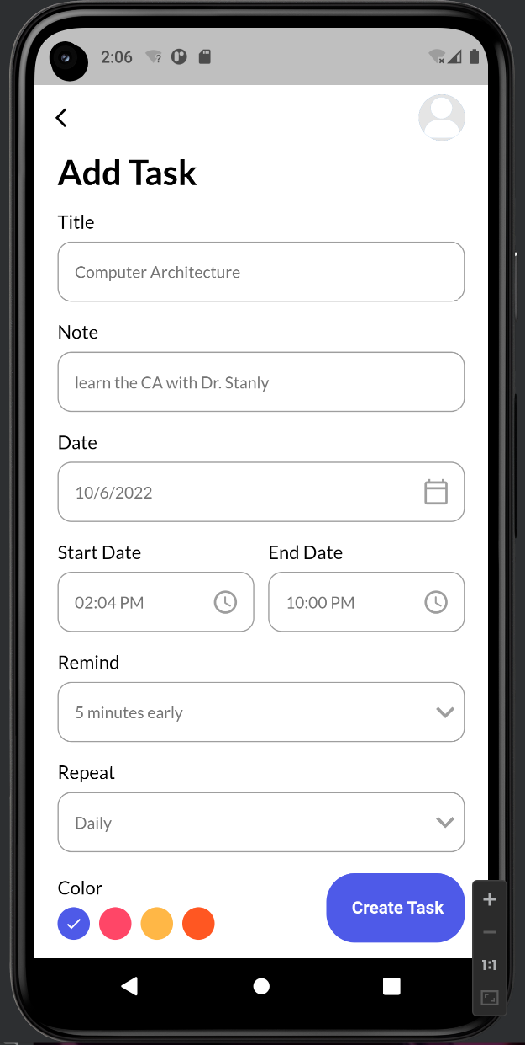 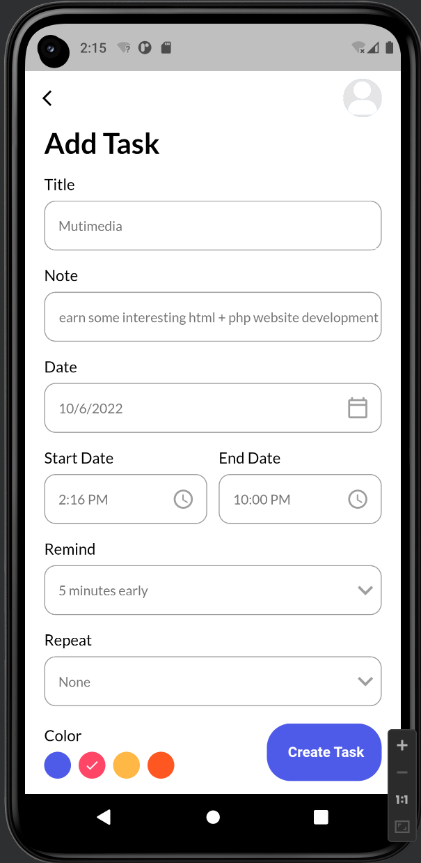

1. Task date select function

You can choose the day in the calendar to see this day any task you have.

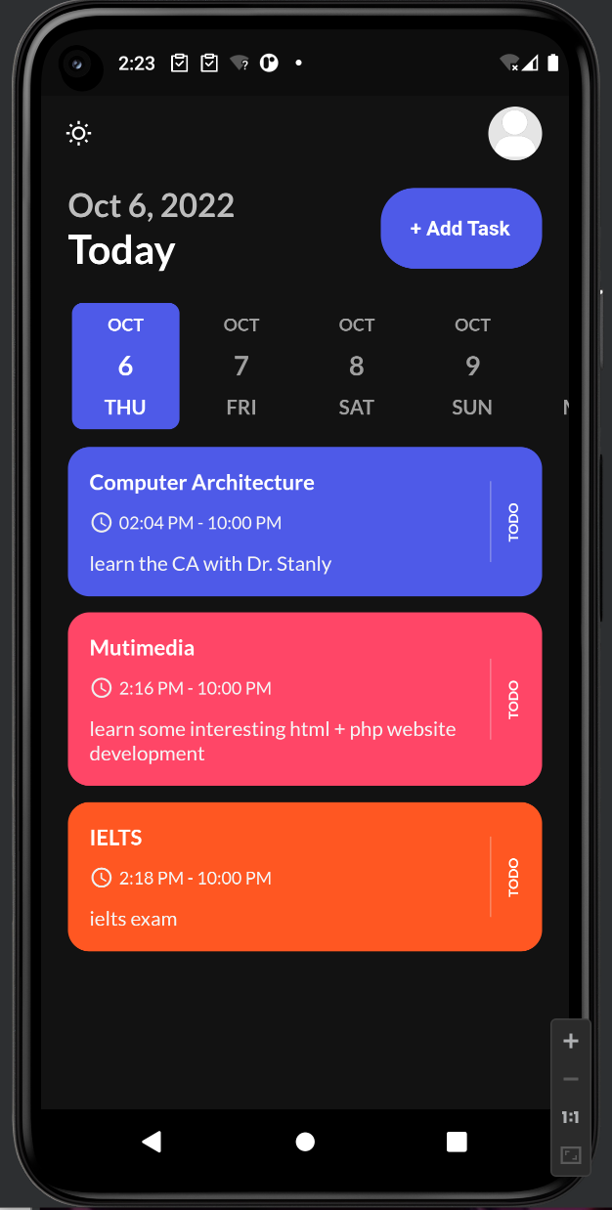 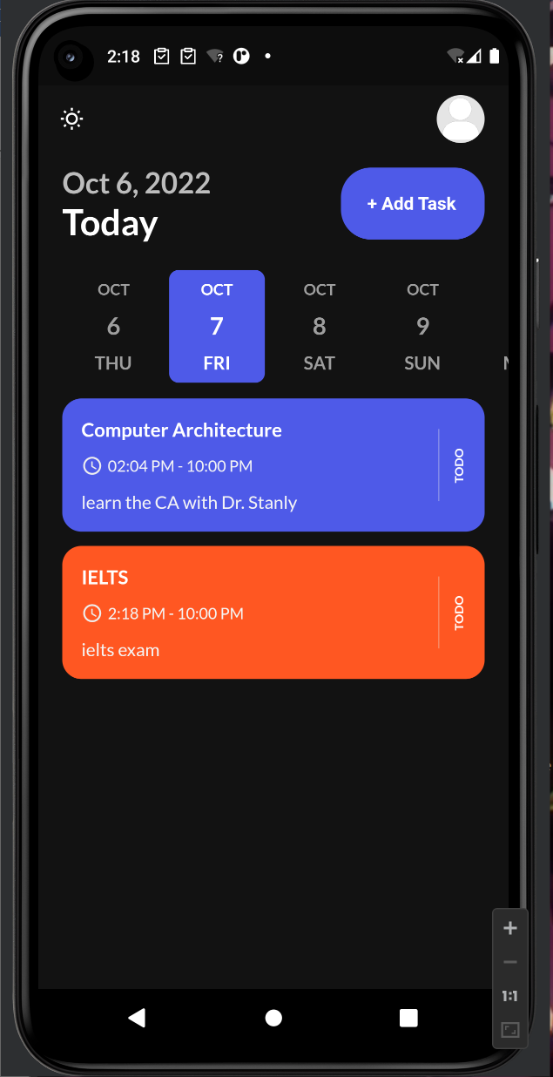

1. Task completed/delete

When your task is done, you can set it as completed or deleted it.

Original task home page:

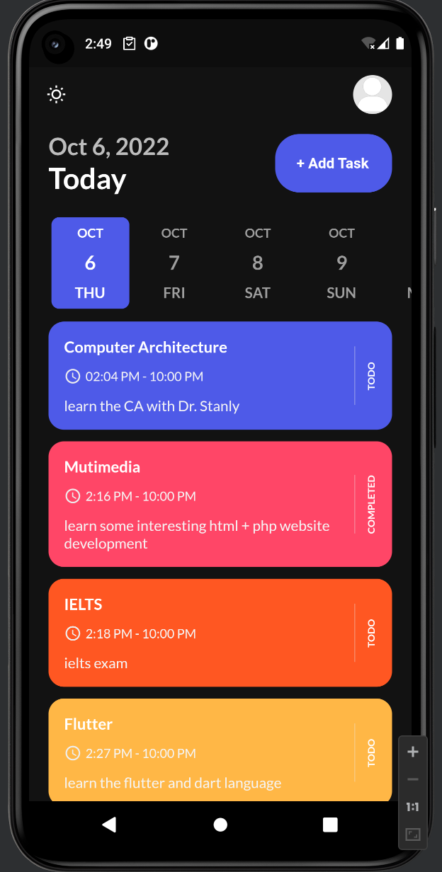

After set task “Computer Architecture” as “Completed”:

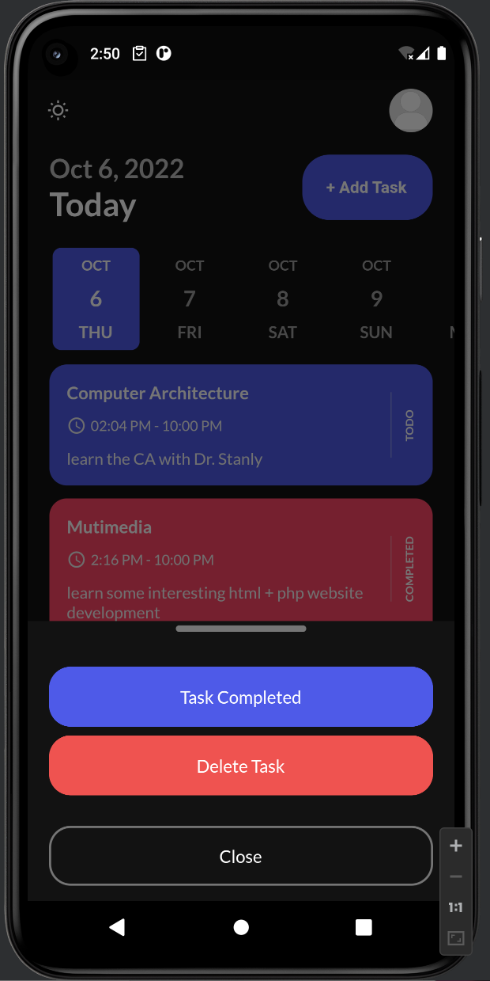 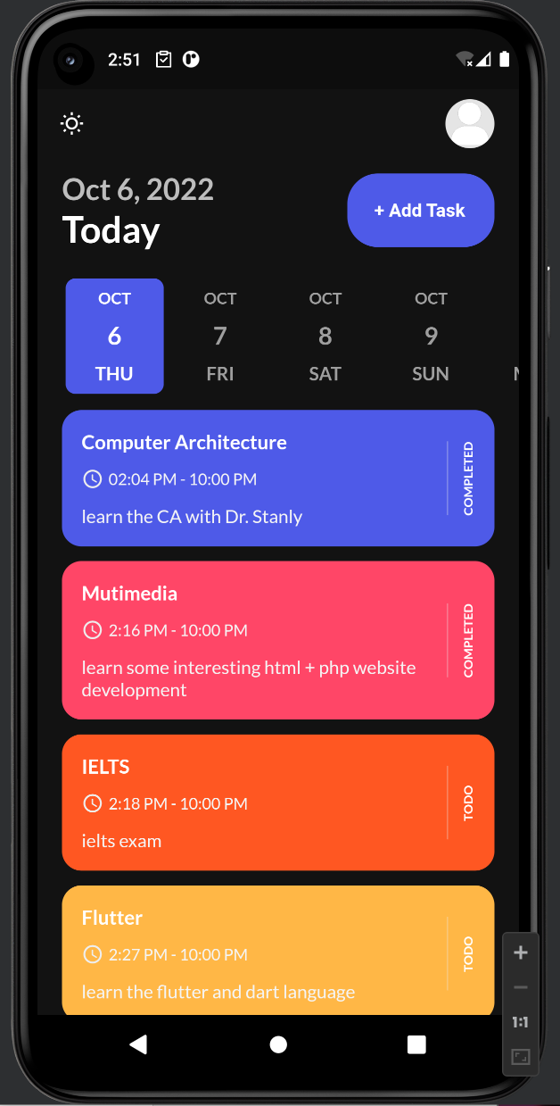

*Maybe consider add the uncompleted button otherwise user can only delete it after set it as completed.

1. Link to database

We have to link all the message and element of our task to the database later…

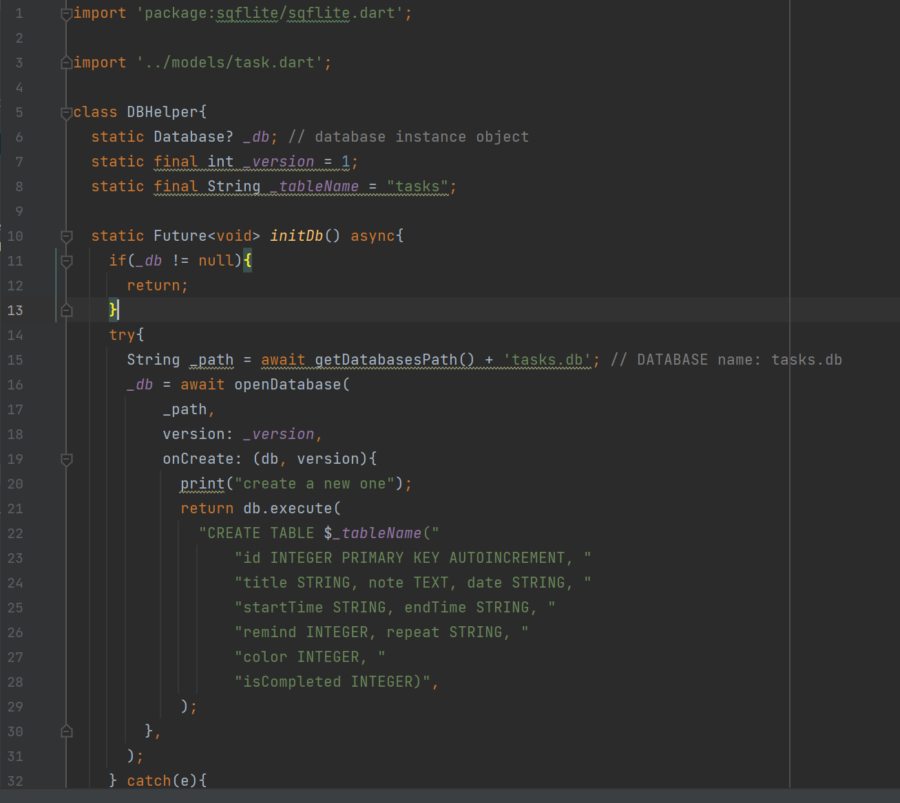

**Conclusion**

In conclude, in this small project I just learned to use these functions:

* Theme mode switch
* Task reminder
* Task Card color theme
* Date dashboard
* Time calendar function

So far my thought is that, add this reminder function in the student side view, so that the student can clear know which day they have tasks, remind them before the task deadline…

And later I will try to add these functions and element after consideration and balanced in our prototype before.

Maybe I should make a new prototype using Figma later…

**Task Reminder App download link(Android)**

<https://xmueducn-my.sharepoint.com/:u:/g/personal/cst1909128_xmu_edu_my/EXALWjWGutVMtwLuz-PC1ncBHVBstlWWLyapDfnfG2rBIQ?e=uaKNJF>

**Figma Prototype:**

<https://www.figma.com/proto/uJzJKBsqYq6PJWWApKvH8D/Task-todo-app?node-id=204%3A1086&scaling=scale-down&page-id=0%3A1&starting-point-node-id=204%3A1086&show-proto-sidebar=1>

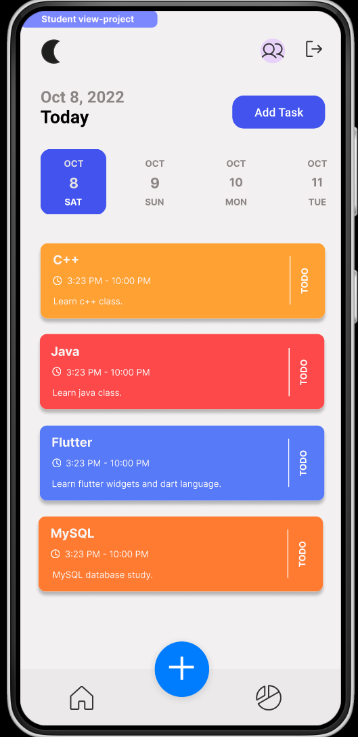 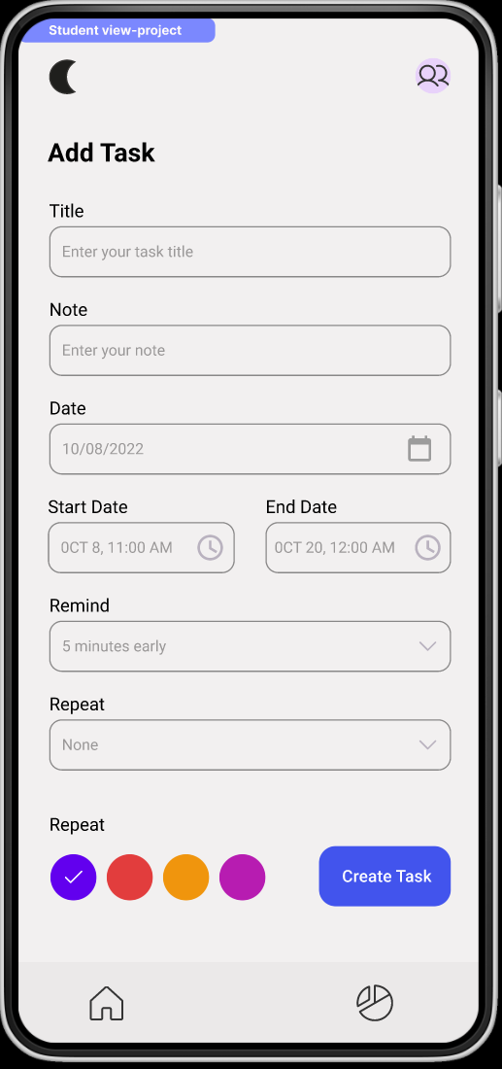 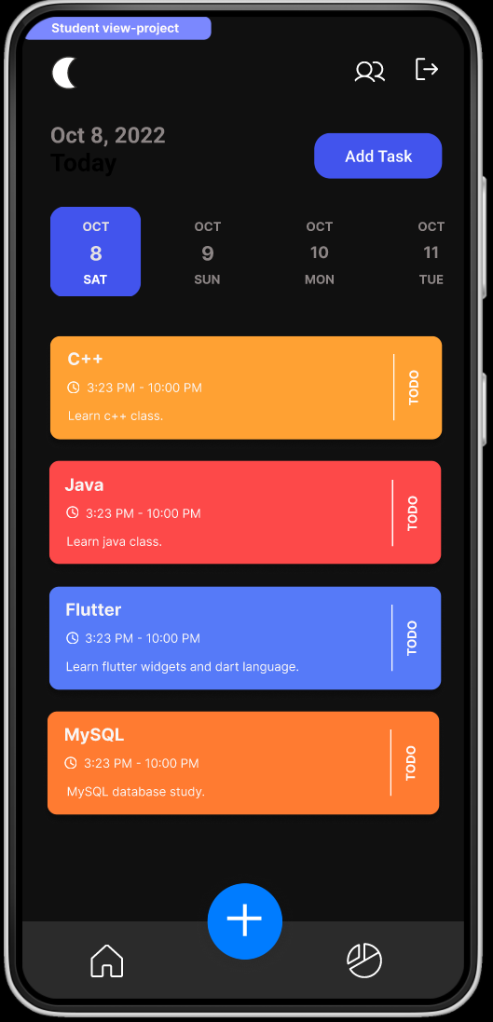

**References**

1. <https://www.figma.com/file/Ov78s8cJULkGQVbWPbwXX5/Taska---Task-%26-Project-Management-App-UI-Kit-(Community)?node-id=0%3A1>
2. <https://www.figma.com/community/file/1123285642743085306>
3. <https://www.figma.com/file/Ov78s8cJULkGQVbWPbwXX5/Taska---Task-%26-Project-Management-App-UI-Kit-(Community)?node-id=0%3A1>
4. <https://www.figma.com/file/W6xZ9OXR5tVT7yWC08SvWe/Task-scheduler-(Community)?node-id=0%3A1>

考虑把Start Date 和 End Date 换成 Due day